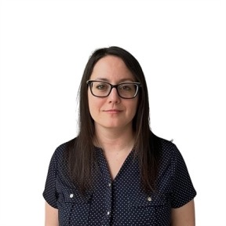

Sasha Rodriquez - Recruiter

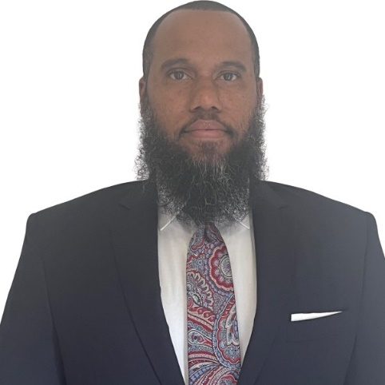

Terrence Vick – Account Manager

Kelly Educational Staffing provides us with substitutes for Nutrition, Teachers, and Paraprofessionals. If you would like to become a sub for the Richmond County Board of Education, you can call 1-800-528-0049 option 2 or use the following link which will allow you to schedule an appointment for an interview directly with Kelly recruiter Stasha Rodriguez. Kelly Education is located at 1450 Greene St. Suite 150, Augusta, GA 30901 inside of the Enterprise Mill.

[https://calendly.com/south-education-angie-douglass/richmondcounty?month=2024-07](https://nam11.safelinks.protection.outlook.com/?url=https%3A%2F%2Fcalendly.com%2Fsouth-education-angie-douglass%2Frichmondcounty%3Fmonth%3D2024-07&data=05%7C02%7CLemonSh%40BOE.richmond.k12.ga.us%7Cfcf87249c2fd42d3ecb208dc99e6c46e%7C30b22d4073624f1783a92530927b6f65%7C0%7C0%7C638554463648796640%7CUnknown%7CTWFpbGZsb3d8eyJWIjoiMC4wLjAwMDAiLCJQIjoiV2luMzIiLCJBTiI6Ik1haWwiLCJXVCI6Mn0%3D%7C0%7C%7C%7C&sdata=b6MR5f8Xhk4u%2BdXnIkhUtpgy9kmijfluEgVKk4LEhgA%3D&reserved=0)